Determination of the 2006 fireball rate from continuous CCD fisheye monitoring

A. P. Ames¹, J. L. Huyck¹, C. E. Butler¹, B. C. Johnson¹, T. Pickering², and R. J. Nemiroff¹
¹Physics Department, Michigan Technological University, Houghton, MI
²MMT Observatory, University of Arizona, Mount Hopkins, AZ

ABSTRACT
Images from a fisheye, CCD, all-sky camera at the MMT in Arizona taken between May 2006 and April 2007 were visually inspected for bright visual fireballs. Two undergraduate observers (APA & CEB) independently scanned web-assessable archived digital movies composed of consecutive 10-second frames, recording sky coordinates at opposite ends of every perceived meteor trail. Given daylight, moonlight, and inclement weather constraints, fireballs were recordable about 10 percent of the time. After critically contrasting the data sets, about 220 candidate fireballs remained, many of which were clearly associated with known meteor showers. Once the visible meteors were located, stars were used for a comparison to find the apparent magnitude of the fireballs. All meteors magnitudes were estimated visually by matching the brightest part of the meteor trail to a nearby star of similar luminosity. Plots of the fireball rate and luminosity over the observing period are included.

1 INTRODUCTION

How frequently do fireballs occur on the sky? Bright meteor events like fireballs are commonly reported, particularly during known meteor showers, but the event rate is typically determined solely by human observers. Outside of meteor showers, event rates are not as well documented. In this work, we have used a combination of fisheye CCD images and human sight to make an estimate of the fireball rate during the year 2006.

Paragraph on previous work done by others.

Paragraph saying what was done here, section by section.

2 EXPERIMENTAL SETUP

The equipment used to locate the meteors was available over the web through the recorded video files of a CCD camera located at the MMT Observatory. This video camera contains a fisheye lens with an auto iris port that allows for continuous operation. The field-of-view of the camera is a measured 150 degrees. Images of the night sky are acquired every ten seconds, with each exposure lasting eight and a half seconds. It captures objects of up to a 6.8 magnitude. Videos from each night are then archived and made web-assessable, available for our meteorological analysis.
Whenever a meteor appeared in an image, its position and timing were recorded. A program was then created in Matlab that would translate the x-y coordinates of a meteor in the camera image to its corresponding right ascension and declination position in the sky. The program output was verified to be correct to within half a degree of declination and twenty minutes of right ascension. This was accomplished by comparing known stars that appeared in the camera’s field of view with their cataloged coordinates. Eventually, this Matlab program aided us in finding the apparent magnitude of each individual meteor.
For each meteor, a “comparison star” was found deemed similar to the brightest part of the meteor’s trail. After obtaining the star’s position, it could be identified in a star catalog, which listed its apparent magnitude. We analyzed 190 meteors with this method giving us a rough estimate of the peak brightness of the observed meteors.
All the video files were downloaded from the MMT Observatory website. Each file is a compressed DivX avi video format. Since no media player would play these files at a frame by frame rate, we had to resort to converting the files to another format. The program used to accomplish this task was a free video converter called Stoik Video Converter. The video files were then converted to an uncompressed avi file approximately seven gigabytes in size. The uncompressed format was necessary because the original size need to remain the same. QuickTime was then used to observe the files, which allowed a frame by frame observation. This viewing was extremely important because most meteors (except exploding meteors) only visually last for no more than one frame or eight and a half seconds. Most meteors only appear for at most five seconds.

3 DATA COLLECTION

Whenever a meteor appeared in a frame, its position and timing were recorded. After all the meteors were located, comparison stars of a similar apparent magnitude to that of the meteors’ brightest spot in its tail were visually located. Each of the 200 meteors were all compared to their own star. This was independently accomplished by two undergraduate researchers (APA and JLK).
After the location of these stars were recorded a Matlab program, which was written by another undergraduate (BCJ), was used to translate the xy-coordinates of the image file to the corresponding Right Ascension and Declination in it’s positioning the night sky. When all 200 stars had the Right Ascension and Declination computed, a star catalog was used to find the apparent magnitude. An upper bound limit was set of a peak magnitude of +6.0. This eliminated three outliers that were assigned a possibly errant peak magnitude of over +7.0. One hundred ninety meteors were compared to stars in this fashion find an apparent magnitude range of roughly +6.0 to -3.0. Once the range was found, the frequency of meteors hitting the Earth’s atmosphere was calculated to be 0.349 meteors per hour.
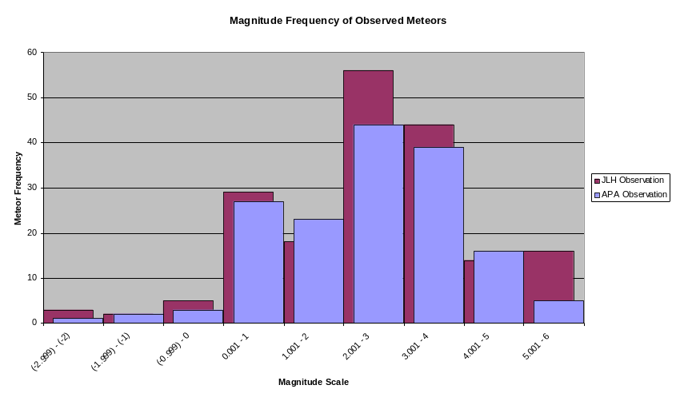
Figure 1
An apparent magnitude comparison between two undergraduate researchers of fireball meteors. The magnitude range is from -3 to +6.

Each night through May 2006 to April 2007 was viewed to find which nights were clear enough to look for visible fireballs. If the night has the moon, clouds, or weather related obstructions for more than fifty percent of the night, the file was eliminated from the data. After this was completed, fireballs were recordable ten percent of the time.
The graph shows the frequency of meteors between the apparent magnitudes. (See Figure 1)
The bright meteors, especially above -2.0 were often from exploding meteors. These types of meteors were rare, occurring at most once a month. The next step was to find the fireball rate for the given range of magnitude. We had to take into account nights that had no visual meteors. This may have occurred for two reasons: there were actually no visual meteor of apparent magnitude of +6.0 or brighter, or the night was not observed due to weather conditions of full moon obstructing vision. All hours were accounted for, even when there were no visible fireballs, when calculating the average meteor rate. The hours used were calculated by going back through the nights and finding exactly the amount used each night. The total observed time was 534 hours. Only eighty-five
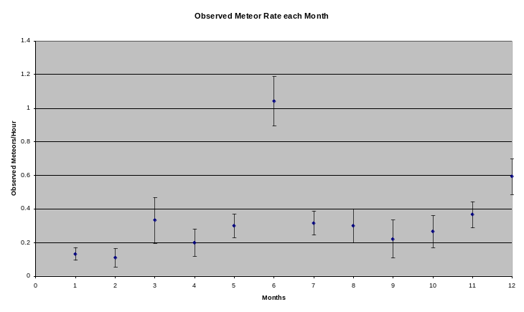
Figure 2
Meteor rate for each month for the calendar year of May 2006 to April 2007. Each month has accompanying error bars.

percent of the night was being view. Taking that into account the actual observable time was 454 hours. With this set of data, a plot was created of the meteor rate for each month with accompanying error bars (shown in Figure 2). The data points that had a higher amount of meteors were due to observed meteor showers seen over the course of the calendar year. These included the Lyrids (April 22), the Orionids (October 22), and the Leonids (November 17). As the data was calculated over a narrower time frame, such as a nightly rate rather than a monthly rate, it was more apparent to make out the occurrence of known showers.

# DISSCUSSION

To the best of our knowledge, we have completed the first machine based search for fireballs from the same location using the same digital video camera over the entire visible sky over the course of an entire year. Expected meteor showers were easily identified, and many sporadic meteors were also observed. The given area we observed, given that the most meteors typically burn up in the mesosphere at a height of 80-90 kilometers, was 280043 kilometers squared. The Earth’s surface area is 510065600 kilometers squared. The percentage we observed was 0.055 percent of the Earth’s surface. The fraction of time we viewed over a given year was 5 percent of the total time. So, given that the meteors would hit the Earth’s surface in a homogeneous distribution, the number of meteors to hit the surface in a given year is 6.5 million meteors between an apparent magnitude of -3 to +6.
Averaged over the entire year, 0.22 +/- 0.07 fireballs/hour with peak brightness greater than visual magnitude 3 were found. (The integrated brightness of the faintest meteors detected typically falls between visual magnitude -2 and visual magnitude 0.)

ACKNOWLEDGEMENTS

REFERENCES

** To add still:
Footnotes
Reference citation

